Technical Study Guide for PM Interviews
By: Rafi Lurie | rafilurie@gmail.com
Current APM at Uber

In most PM Interviews, you will have some sort of assessment of your technical chops. This can mean different things at different companies: some PM’s do not need to be very technical, while others will dig in and write code. However, all product managers will be tasked with communicating, understanding, and translating technical information to both very technical and completely non technical team members.

Like I mentioned, technical knowledge will vary across companies. I would recommend studying both high level technical concepts as well as tactful things like writing code. This guide is not meant to be exhaustive, but a continuing work in progress.

I only ask for three (that’s a lot) things in return:
- If you come across some information that you think would be useful to have here and is missing, please add it. Change from “Viewing” → “Suggesting” in the upper right of Google Docs and add your suggestions.
- If you’d like to give feedback on the content, leave a comment on the doc using Google Doc’s comment feature (in the action bar to the left of the text alignment buttons)
- If you know someone who might find this document useful, send it their way

Thank you for passing it forward, and good luck!

-------------------------------------------------------------------------------------------------------------------------------

Table of Contents
Access Times
Stack vs. Queue
Stack vs. Heap (Memory)
How Does a Webapp Work?
How Do Computers Communicate?
How Does the Internet Work?
TCP
Model-View-Controller
Other Things to Know

Related Documents
Interview Question Prep for PM Interviews

Access Times
- Reading from memory 1 microsecond
- Acquiring lock 10 microsecond
- Reading disc 1 millisecond
- Over internet 100 millisecond

Stack vs. Queue
- Stack is a LIFO (last in first out) d ta structure. The associated link to wikipedia contains detailed description and examples.
- Queue is a FIFO (first in first out) data structure. The associated link to wikipedia contains detailed description and examples.

Stack vs. Heap (Memory)
Stack
- very fast access
- don't have to explicitly de-allocate variables
- space is managed efficiently by CPU, memory will not become fragmented
- local variables only
- limit on stack size (OS-dependent)
- variables cannot be resized

Heap
- variables can be accessed globally
- no limit on memory size
- (relatively) slower access
- no guaranteed efficient use of space, memory may become fragmented over time as blocks of memory are allocated, then freed
- you must manage memory (you're in charge of allocating and freeing variables)
- variables can be resized using realloc()

How Does a Webapp Work?
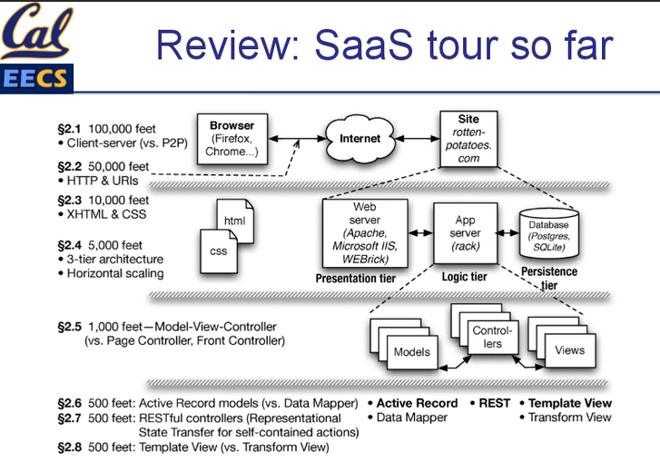

How Do Computers Communicate?
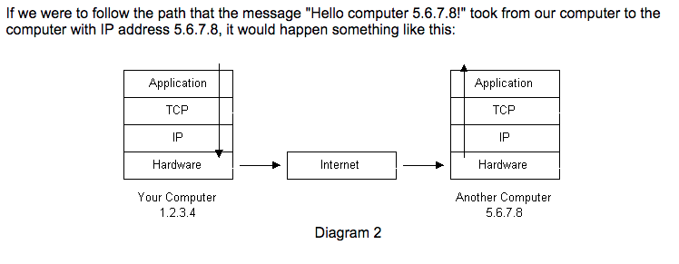
- The message would start at the top of the protocol stack on your computer and work its way downward.
- If the message to be sent is long, each stack layer that the message passes through may break the message up into smaller chunks of data. This is because data sent over the Internet (and most computer networks) are sent in manageable chunks. On the Internet, these chunks of data are known as packets.
- The packets would go through the Application Layer and continue to the TCP layer. Each packet is assigned a port number. Ports will be explained later, but suffice to say that many programs may be using the TCP/IP stack and sending messages. We need to know which program on the destination computer needs to receive the message because it will be listening on a specific port.
- After going through the TCP layer, the packets proceed to the IP layer. This is where each packet receives its destination address, 5.6.7.8.
- Now that our message packets have a port number and an IP address, they are ready to be sent over the Internet. The hardware layer takes care of turning our packets containing the alphabetic text of our message into electronic signals and transmitting them over the phone line.
- On the other end of the phone line your ISP has a direct connection to the Internet. The ISPs router examines the destination address in each packet and determines where to send it. Often, the packet's next stop is another router. More on routers and Internet infrastructure later.
- Eventually, the packets reach computer 5.6.7.8. Here, the packets start at the bottom of the destination computer's TCP/IP stack and work upwards.
- As the packets go upwards through the stack, all routing data that the sending computer's stack added (such as IP address and port number) is stripped from the packets.
- When the data reaches the top of the stack, the packets have been re-assembled into their original form, "Hello computer 5.6.7.8!"

When you type a URL into a web browser and hit ‘enter’, what happens?
- If the URL contains a domain name, the browser first connects to a domain name server and retrieves the corresponding IP address for the web server.
- The web browser connects to the web server and sends an HTTP request (via the protocol stack) for the desired web page.
- The web server receives the request and checks for the desired page. If the page exists, the web server sends it. If the server cannot find the requested page, it will send an HTTP 404 error message. (404 means 'Page Not Found' as anyone who has surfed the web probably knows.)
- The web browser receives the page back and the connection is closed.
- The browser then parses through the page and looks for other page elements it needs to complete the web page. These usually include images, applets, etc.
- For each element needed, the browser makes additional connections and HTTP requests to the server for each element.
- When the browser has finished loading all images, applets, etc. the page will be completely loaded in the browser window.

TCP
TCP works like this:
- When the TCP layer receives the application layer protocol data from above, it segments it into manageable 'chunks' and then adds a TCP header with specific TCP information to each 'chunk'. The information contained in the TCP header includes the port number of the application the data needs to be sent to.
- When the TCP layer receives a packet from the IP layer below it, the TCP layer strips the TCP header data from the packet, does some data reconstruction if necessary, and then sends the data to the correct application using the port number taken from the TCP header.
This is how TCP routes the data moving through the protocol stack to the correct application.

Model-View-Controller
Divides an application into three kinds of components: (more info here)
- A controller can send commands to the model to update the model's state (e.g., editing a document). It can also send commands to its associated view to change the view's presentation of the model (e.g., by scrolling through a document).
- A model notifies its associated views and controllers when there has been a change in its state. This notification allows the views to produce updated output, and the controllers to change the available set of commands. In some cases an MVC implementation might instead be "passive," so that other components must poll the model for updates rather than being notified.
- A view requests information from the model that it uses to generate an output representation to the user.

Other Things to Know
- Concurrency
- Threads/locks
- Recursion
- Divide and conquer
- B-Tree
- DFS/BFS
- Big-O Cheat Sheet, Plain English Explanation of Big-O
- How Does the Internet Work

